**Nucleus Detection and Segmentation**

**Abstract**

The nucleus is an organelle that is present in all eukaryotic cells, including human cells. Abnormal nucleus shapes can be used to identify cancer cells (eg, cervical smears and diagnosis of cervical cancer). Similarly, a growing body of literature indicates that there is a link between the shape of the nucleus and human disease states such as cancer and aging. Therefore, quantitative assessment of nuclear size and shape has important biomedical applications. Methods for assessing kernel size and shape typically involve identifying cores by conventional image segmentation methods. Here, we show a deep learning method for identifying and segmenting nuclei from cell images. We use a CNN model to recognize these images, the recognition rates reached above 97%.

**Keywords**

Artificial Intelligence, Python, Recognition, Tensorflow, CNN, Deep Learning

**2.Introduction**

2-1 Background

We’ve all seen people suffer from diseases like cancer, heart disease, chronic obstructive pulmonary disease, Alzheimer’s, and diabetes. Identifying the cells’ nuclei is the starting point for most diseases analyses because most of the human body’s 30 trillion cells contain a nucleus full of DNA, the genetic code that programs each cell.

2-2 Motivation

By far, success rates of the CNN methods, which based on mainstream deep learning structure, can be over 97% on the benefit of the development of the convolutional neural network technology, and this is different from the traditional machine learning methods.

2-3 Our Approach

Convolution Neural Network (CNN), focusing on end-to-end routine, which is: Inputting the whole image, and this is much more common-use.

**3. Methods**

We use CNN as our main approach to do our project. In machine learning, CNN is a class of deep, feed-forward artificial neural network that has successfully been applied to analyzing visual imagery. CNNs use a variation of multilayer perceptrons designed to require minimal preprocessing. They are also known as shift invariant or space invariant artificial neural networks, based on their shared-weights architecture and translation invariance characteristics.

3-1.About CNN

Convolutional networks are inspired by biological processes because the pattern of connections between neurons is similar to that of the animal's visual cortex. Individual cortical neurons respond to the independence of prior knowledge, and human effort in feature design is a major advantage.

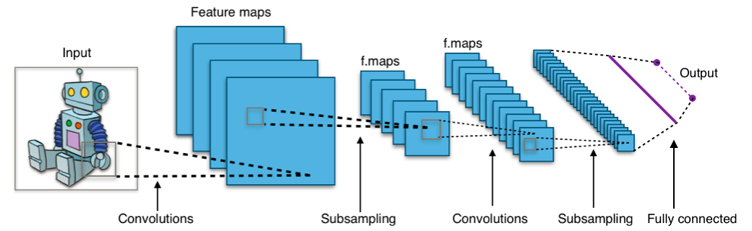

Image 3-1-1

Image 3-1-1 shows the typical architecture of CNN. We can see that the architecture consists of a bunch of different layers that convert the input into output through a differentiable function. Several different types of layers are typically used.

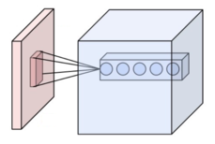

Image 3-1-2

The image 3-1-2 is a structures of a convolutional layer, The parameters of a layer consist of a set of learnable filters (or kernels) that have a small perceived area but extend to the entire depth of the input volume. During forward transfer, each filter convolves over the width and height of the input volume, calculates the dot product between the filter's entries and the input, and produces a two-dimensional activation map of the filter. As a result, the network learns filters that are activated when a particular type of feature is detected at a spatial location in the input.

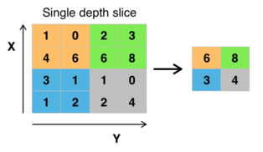

Image 3-1-3

Image 3-1-3 is the sample of the pooling layer. The polling layer operates independently on each depth slice entered and spatially resizes it. The most common form is a pooling layer with a 2x2 size filter that applies 2 downsampled steps along the width and height at each depth slice in the input, discarding 75% of the activation. In this case, each maximum operation exceeds 4 digits. The depth dimension remains the same.

The loss layer specifies how the training penalizes the deviation between the predicted label and the real label, and is usually the last layer. There are various loss functions that are suitable for different tasks, which is our main point of view.

3-2. about U-Net

U-Net is a convolutional neural network developed for biomedical image segmentation at the Department of Computer Science at the University of Freiburg, Germany. The network is based on a fully convolutional network whose architecture has been modified and extended to use fewer training images and produce more accurate segmentation.

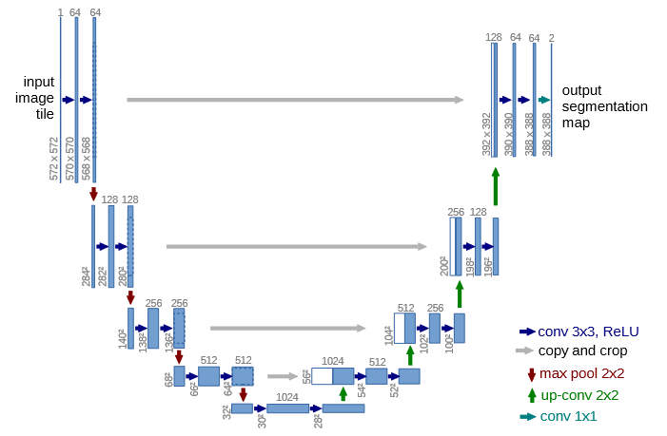

U-net architecture (example for 32x32 pixels in the lowest resolution). Each blue box corresponds to a multi-channel feature map. The number of channels is denoted on top of the box. The x-y-size is provided at the lower left edge of the box. White boxes represent copied feature maps. The arrows denote the diﬀerent operations.

1. **Result**

Prediction Result of Training Set:

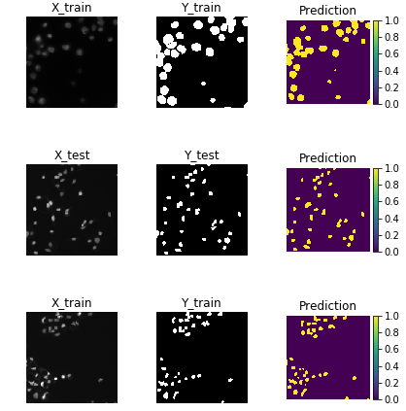 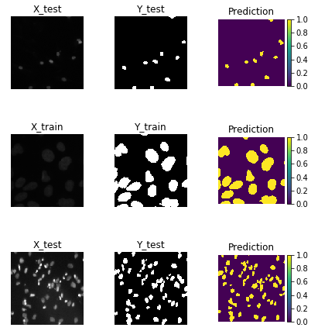

Use tensorboard to monitor the accuracy:

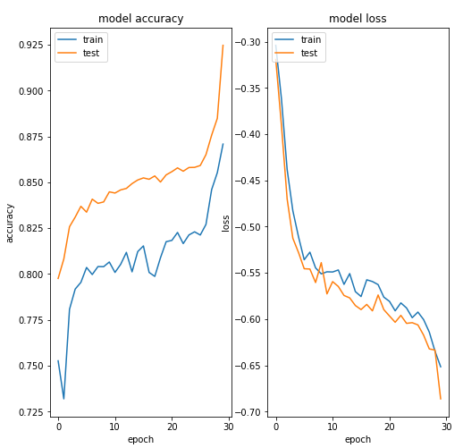

sigmod-6k

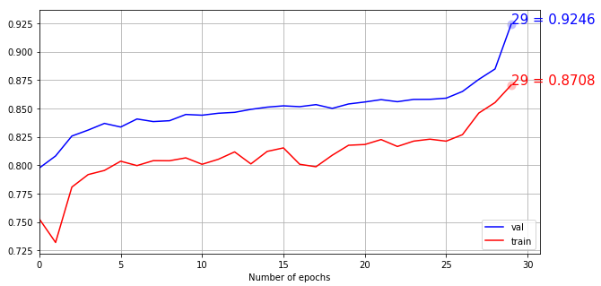

sigmod-8k

After U-Net CNN , we improve the accuracy:

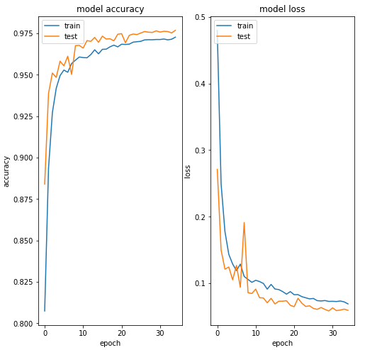

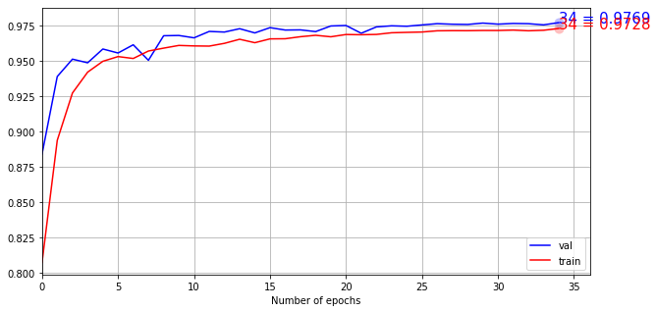

We can see the plot, the train curve has the accurate is 0.8708. the val curve has the accurate is 0.8708. After Using U-Net, the train curve has the accurate is 0.9728. the val curve has the accurate is 0.9769. The results using the U-Net convolutional network are most accurate.

**5. Discussion**

Through the whole process of building our project, we found these different aspects that we want to discuss about.

Based on our results, the traditional identifying code has less accuracy. When we use the U-Net, the accuracy has improved a lot. It is show that the effect of the U-Net in image detection. By increasing the dataset, we can further improve the accuracy of model. We can add more functions, like counting the number of cells in one image.

**references**

1. <https://en.wikipedia.org/wiki/U-Net>
2. <https://arxiv.org/pdf/1505.04597.pdf>
3. <https://en.wikipedia.org/wiki/Convolutional_neural_network>
4. <https://cambridgespark.com/content/tutorials/convolutional-neural-networks-with-keras/index.html>